Frozen Baked Products
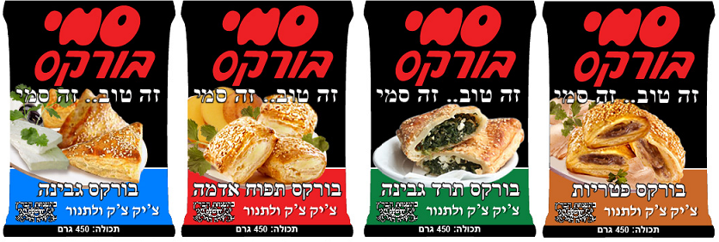
Greek/Turkish Traditional Bourekas

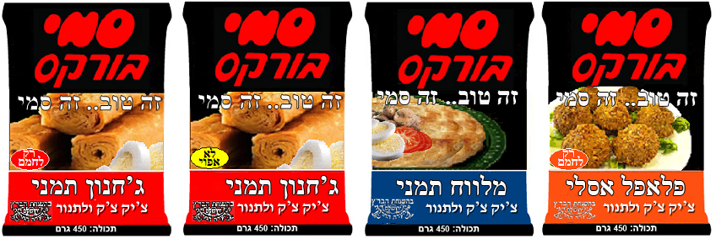
Yemenite Traditional Pastries

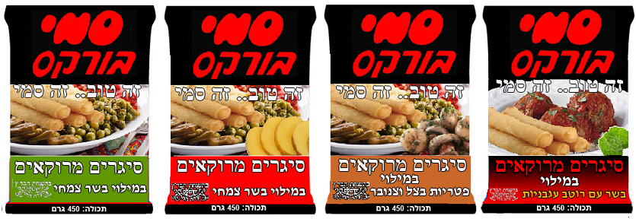
Moroccan Cigars

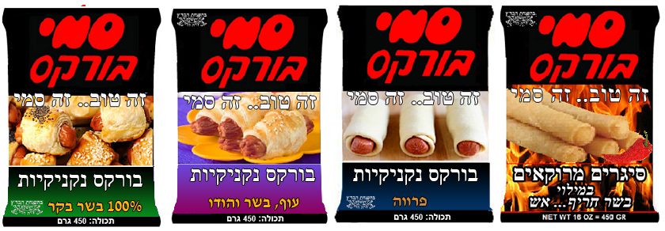
Beef/Chicken Bourekas

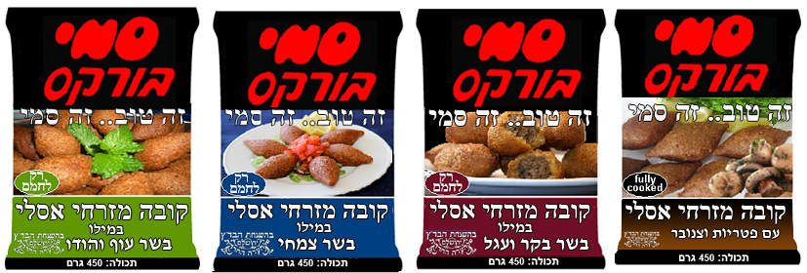
Fully Cooked (Microwaveable) Mediterranean Kibbeh

Fully Cooked (Microwaveable) Ethnic Chinese Egg Rolls
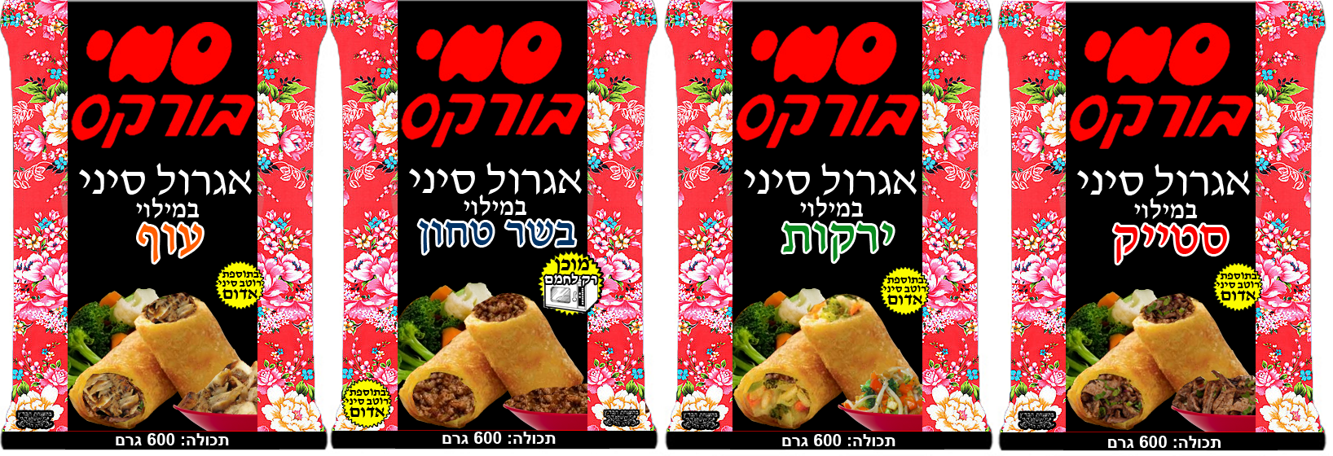

Fully Cooked (Microwaveable) Schwarma Cigars
Chicken Turkey Beef
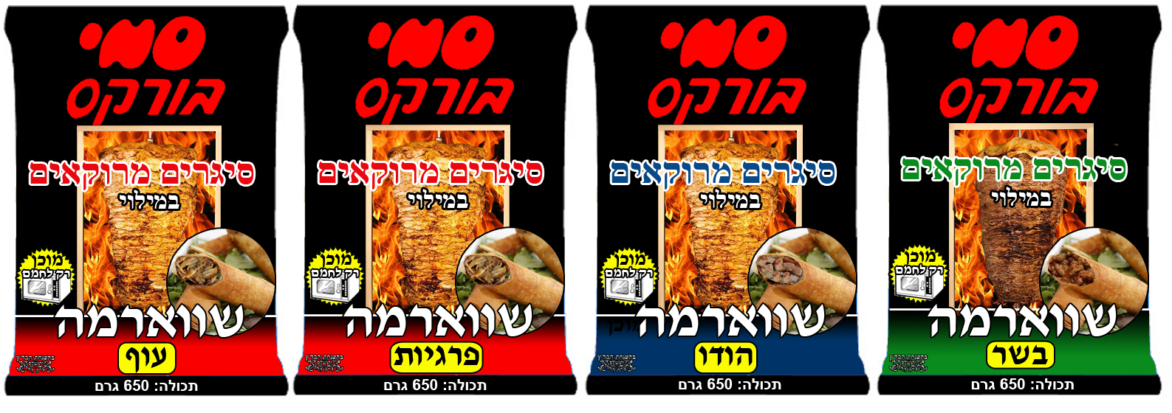
Option 1 Option 2 Option 1 Option 2

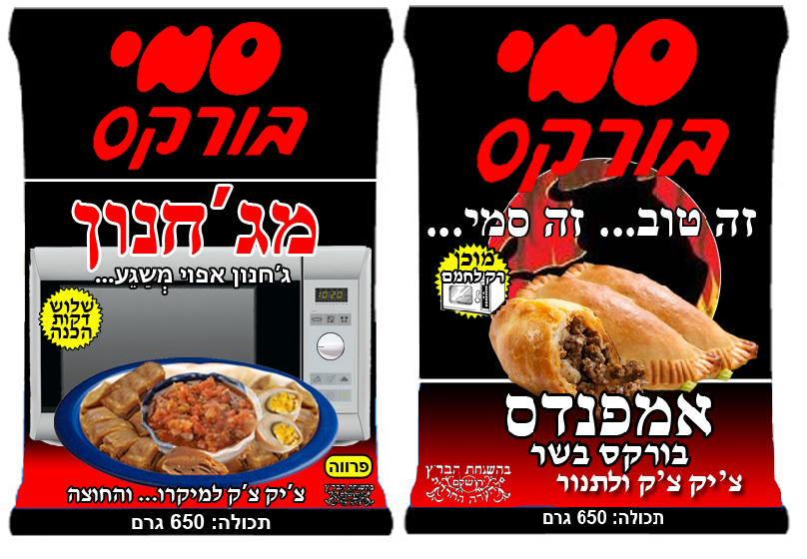
Fully Cooked (Microwaveable)

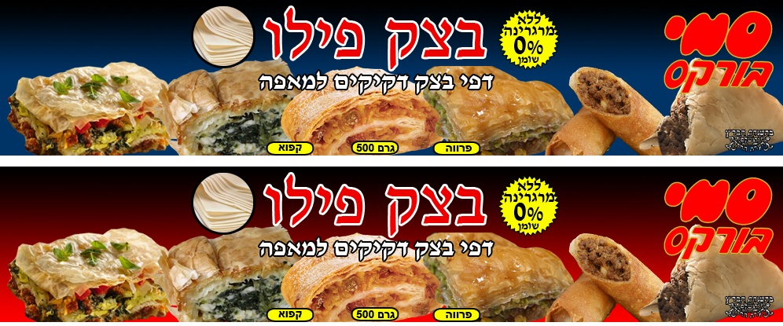
Phyllo Dough

